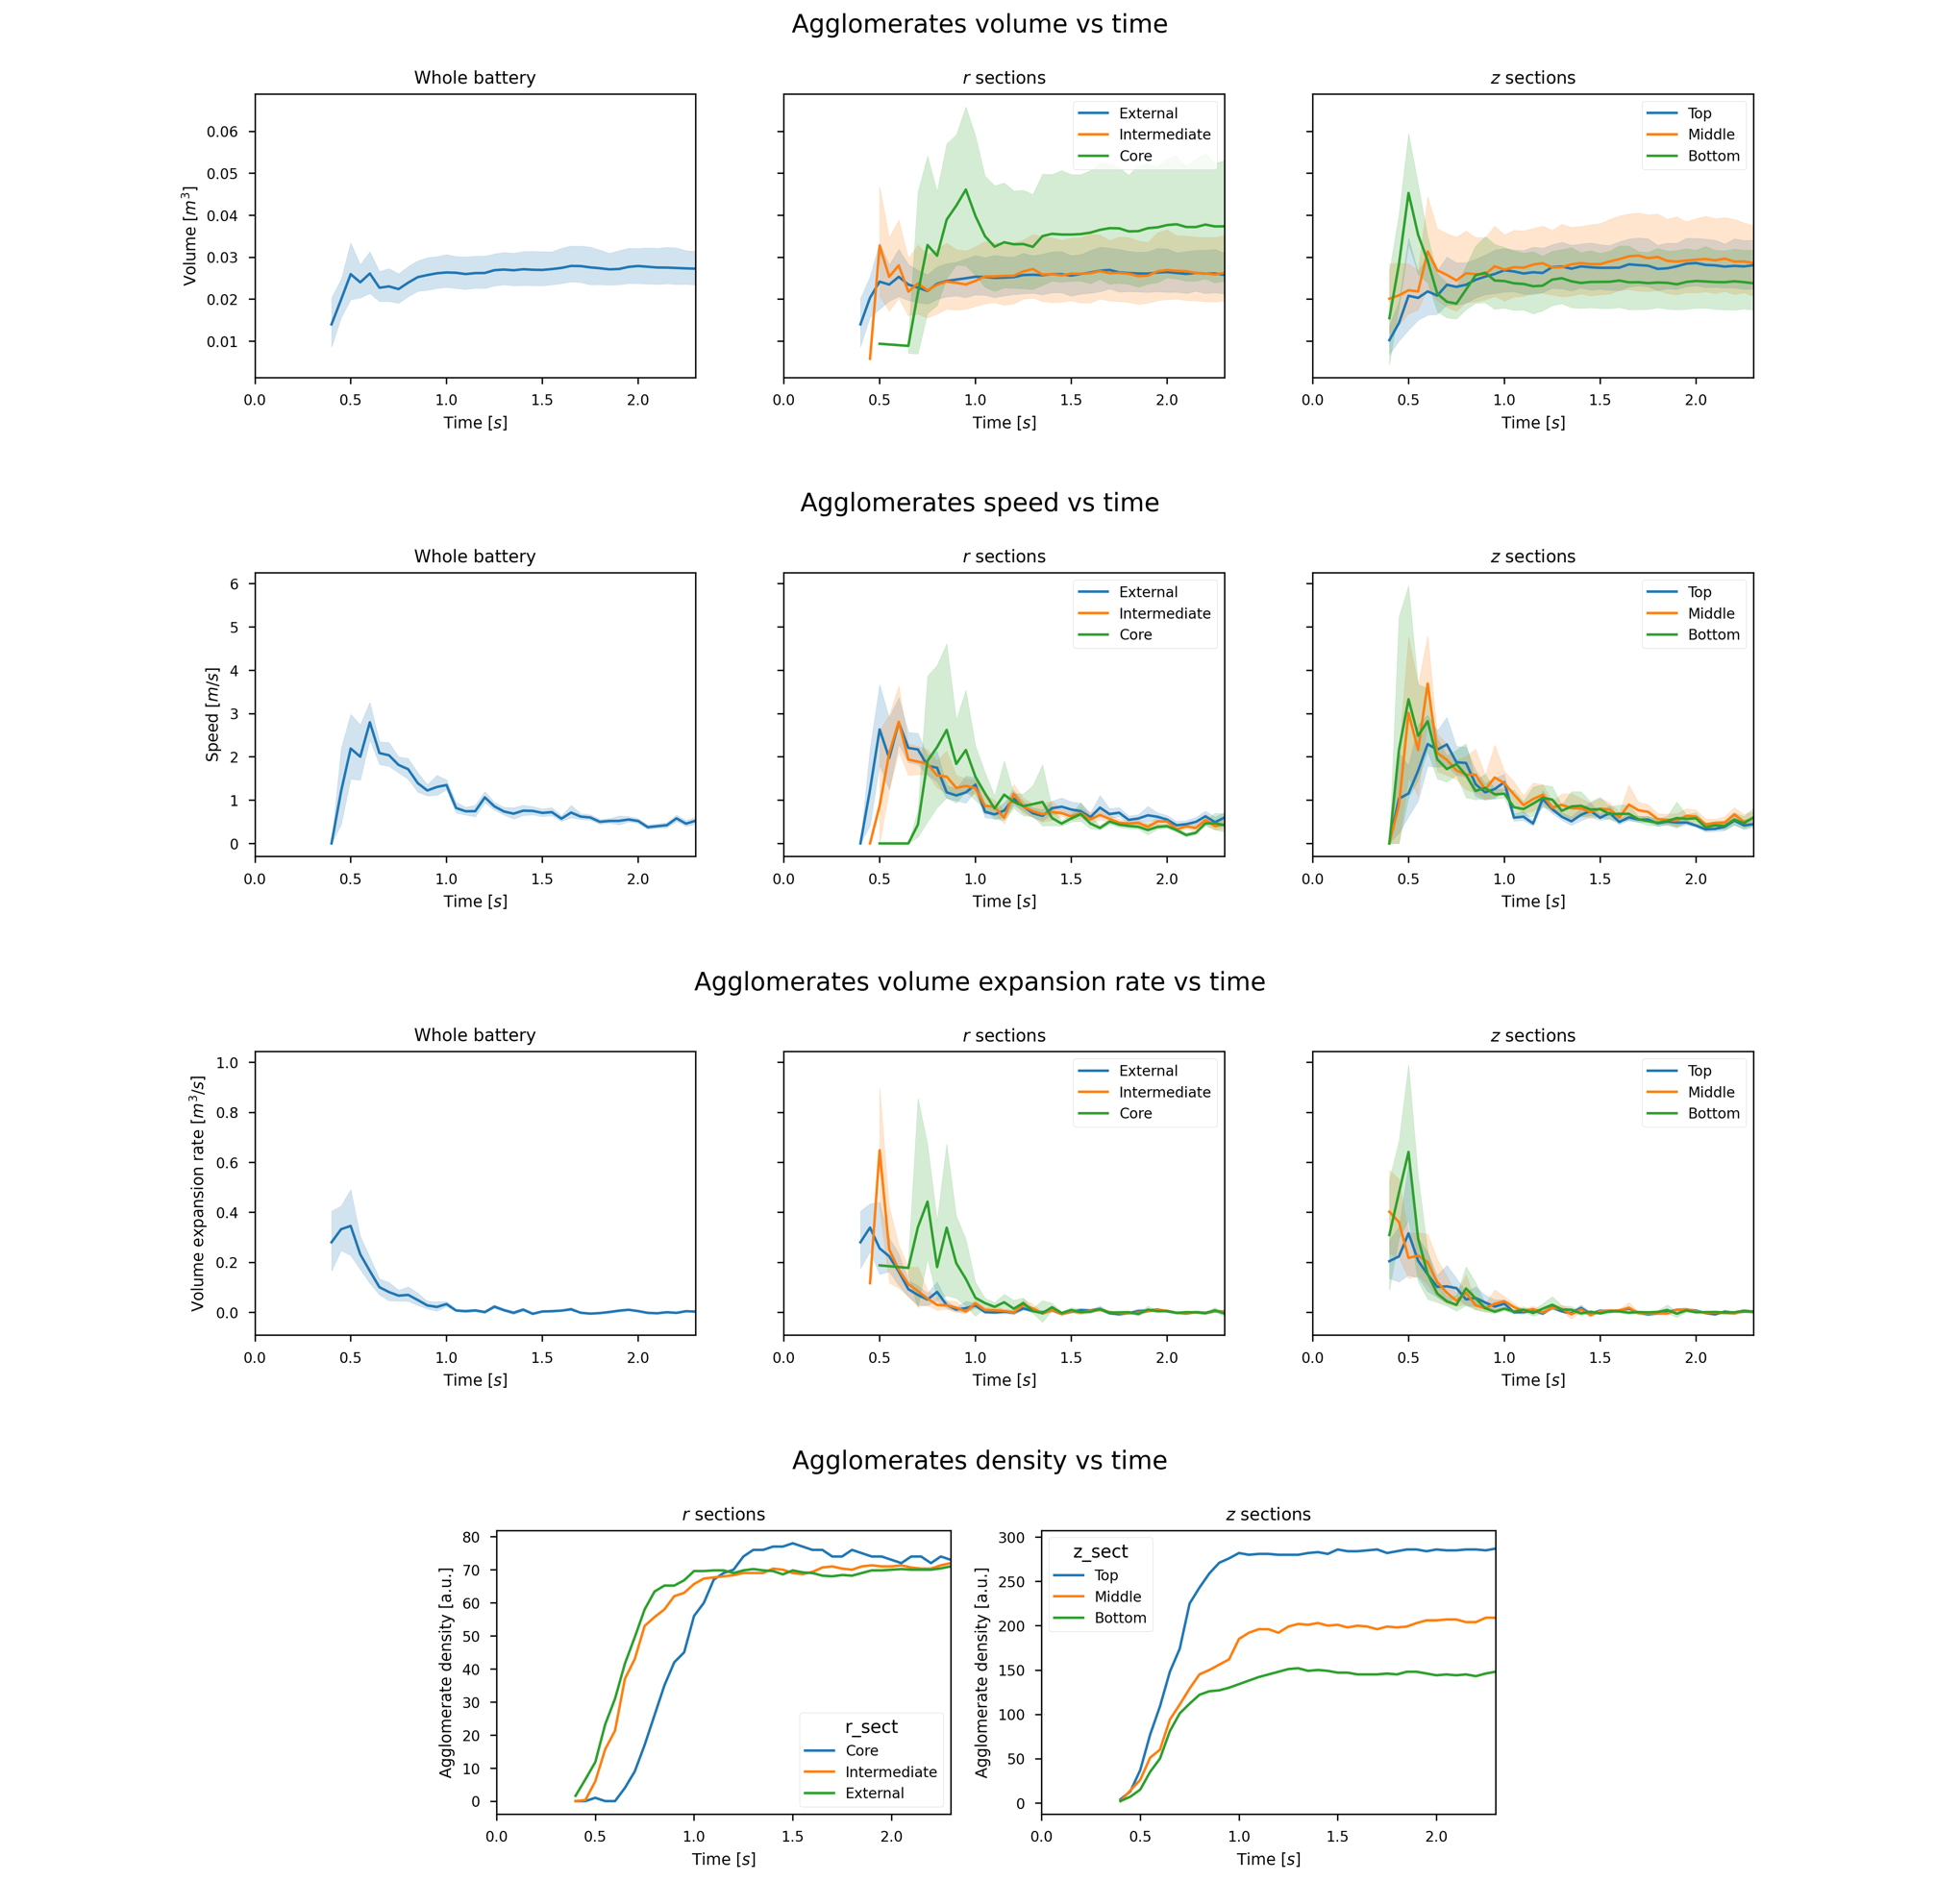P28A_FT_H_Exp1

P28A_FT_H_Exp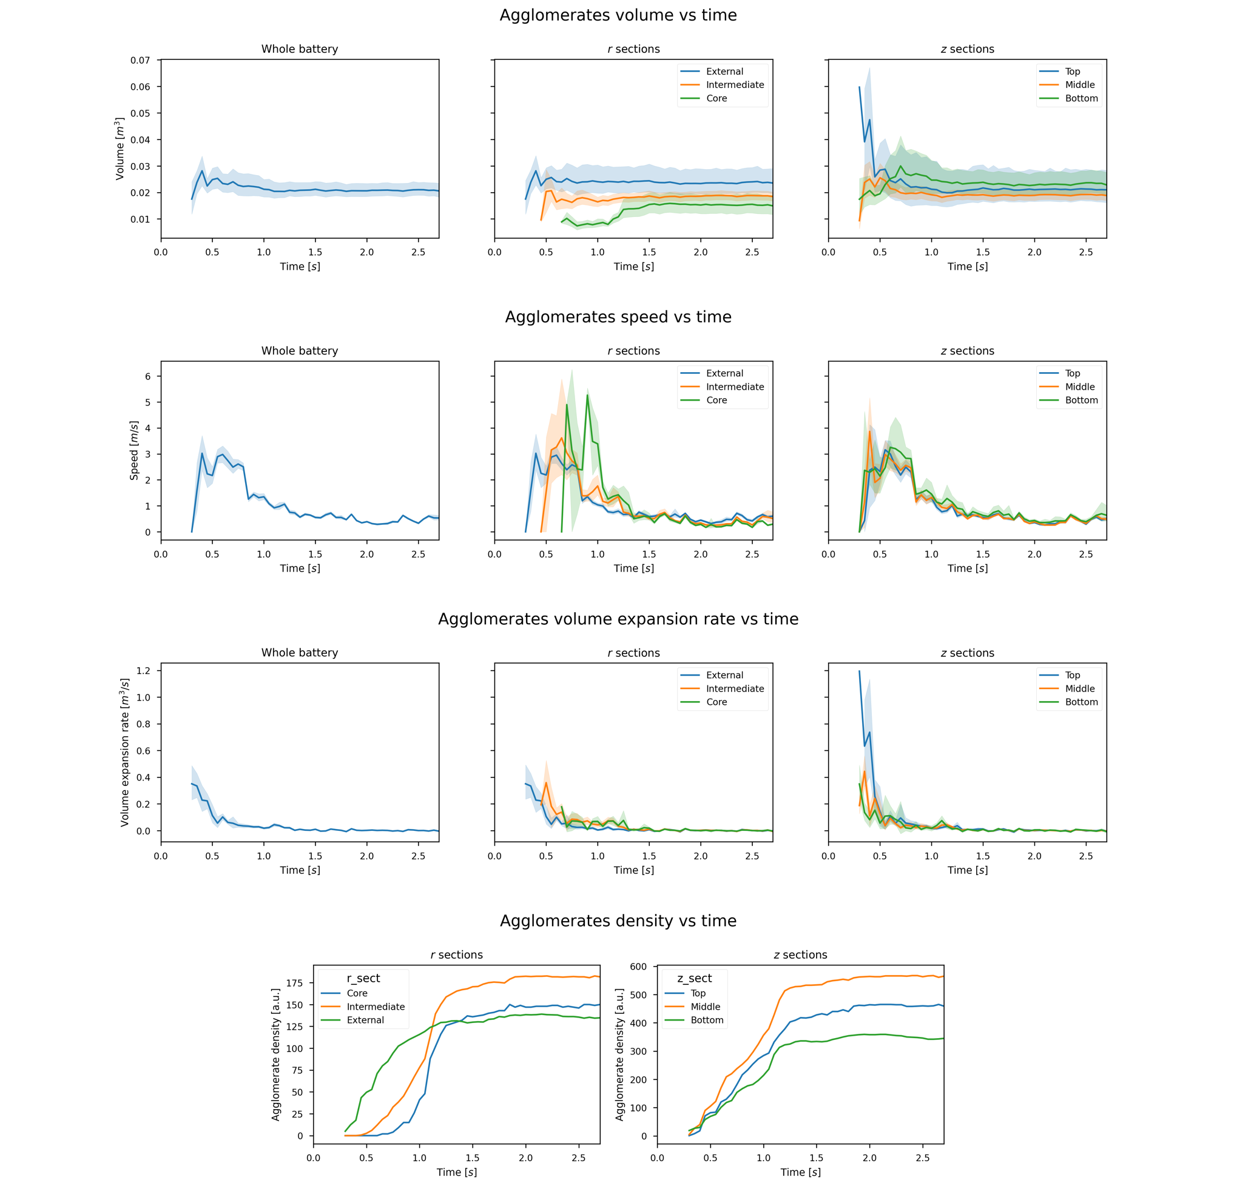2

P28A_FT_H_Exp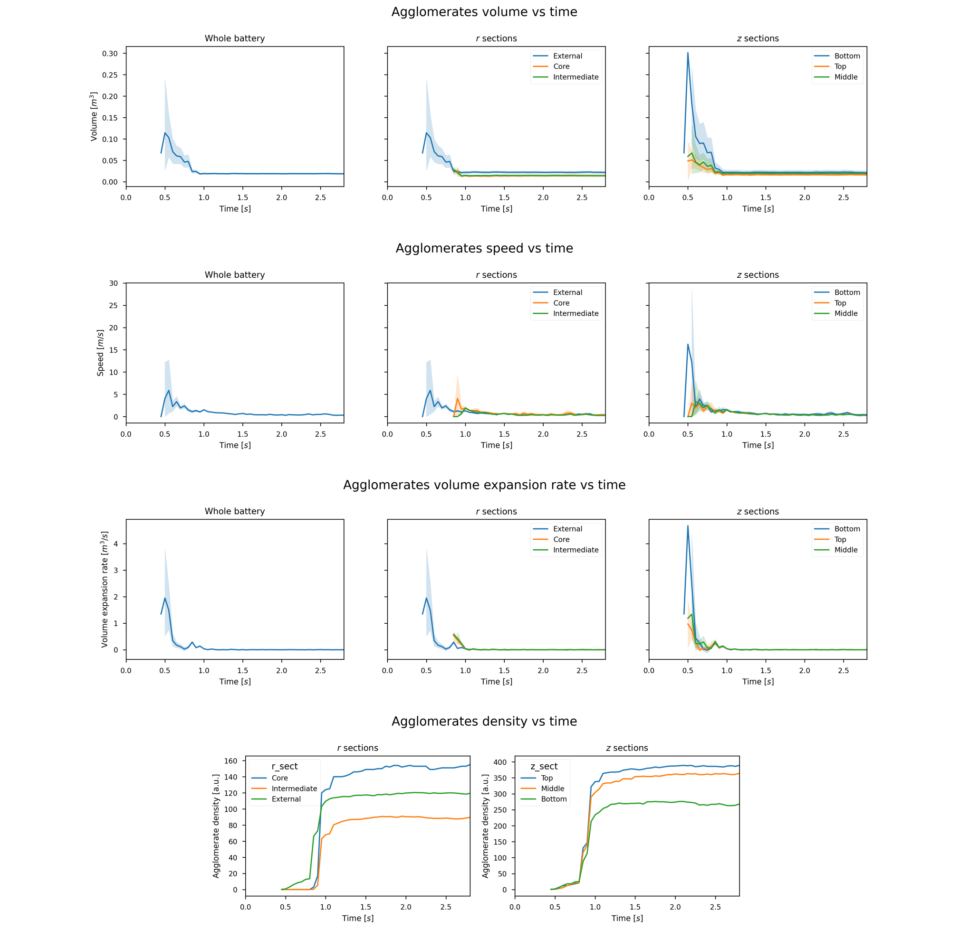3_3

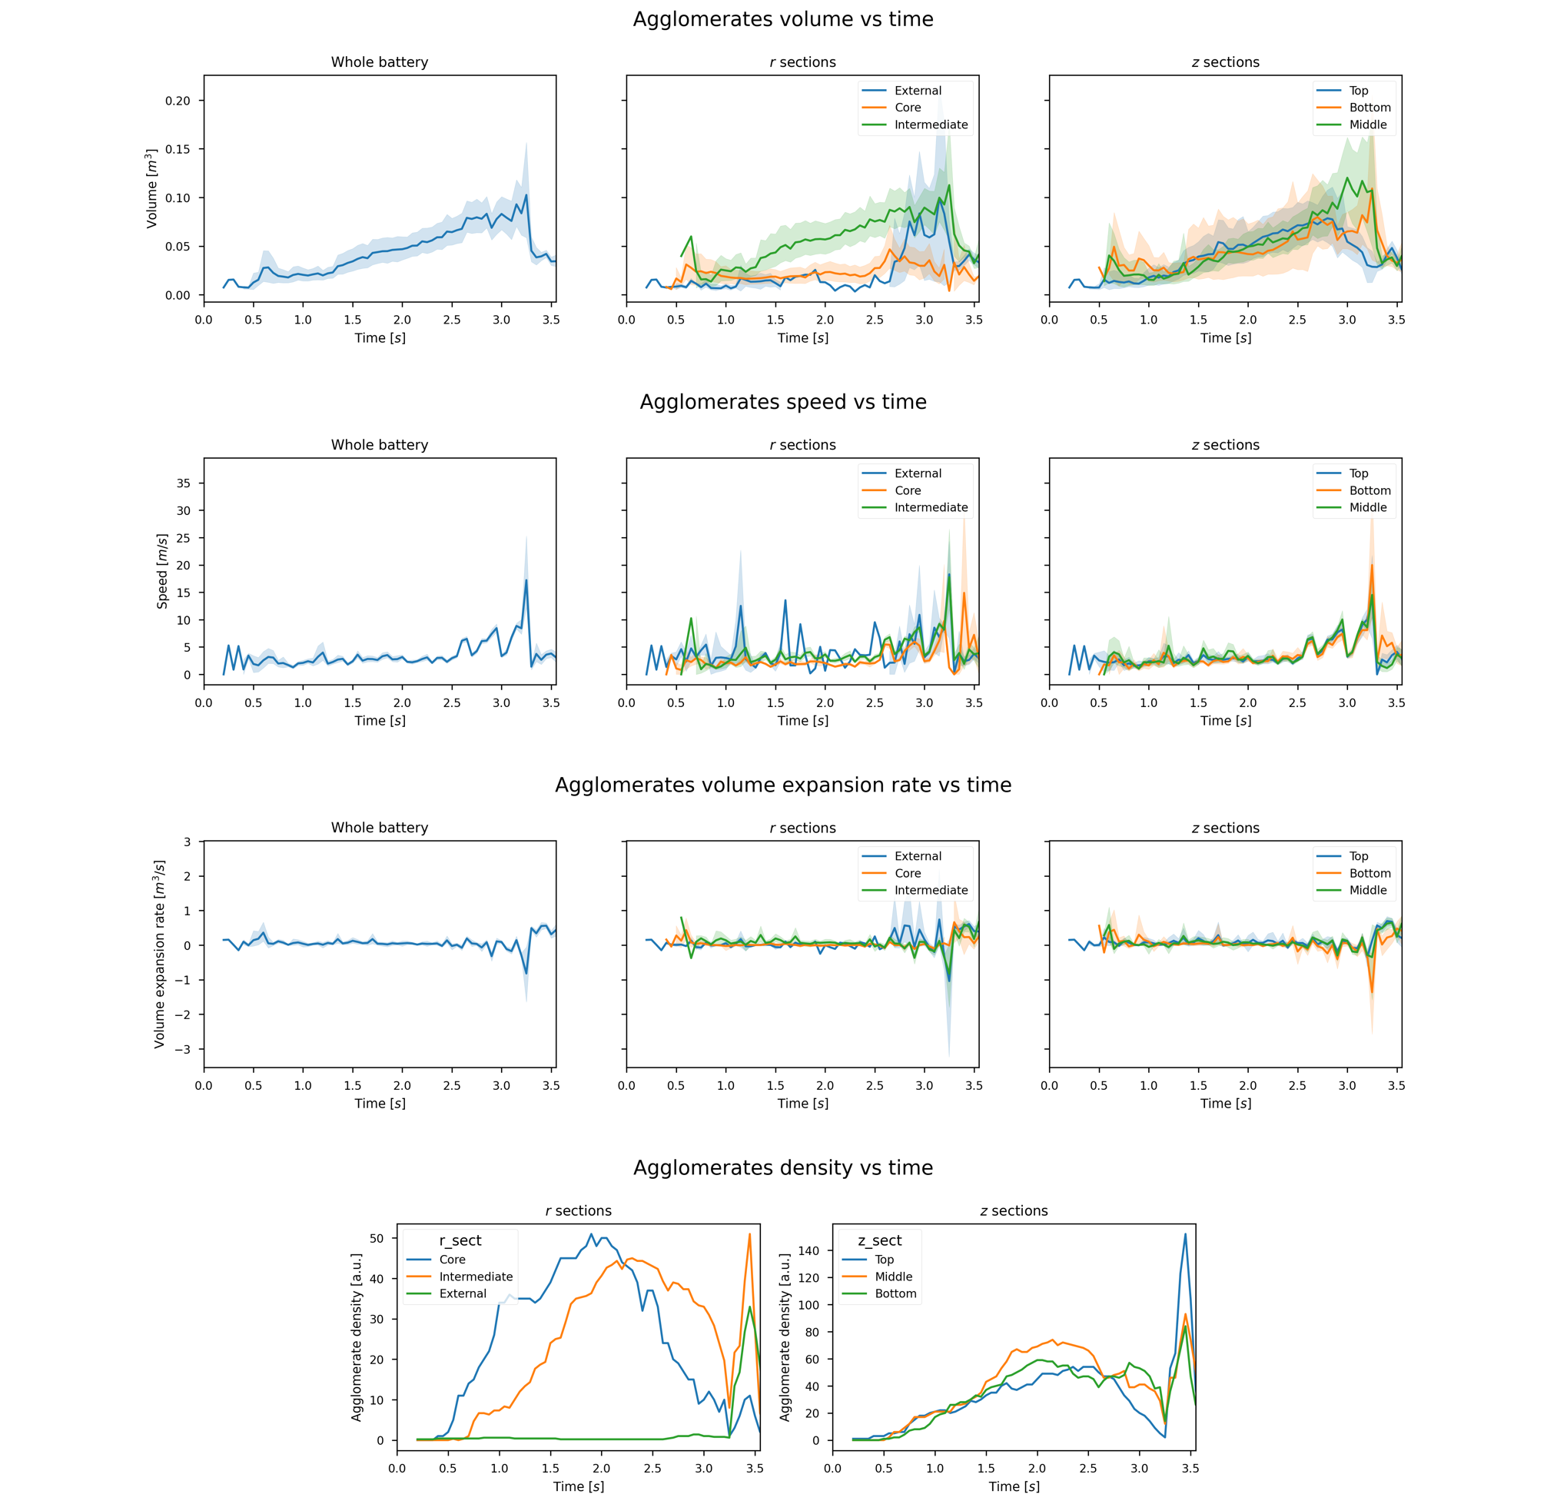VCT5_FT_N_Exp3

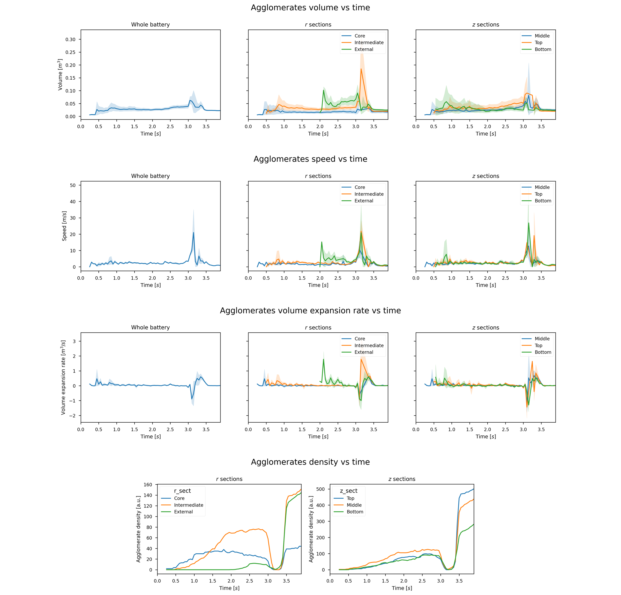VCT5_FT_N_Exp4

VCT5_FT_N_Exp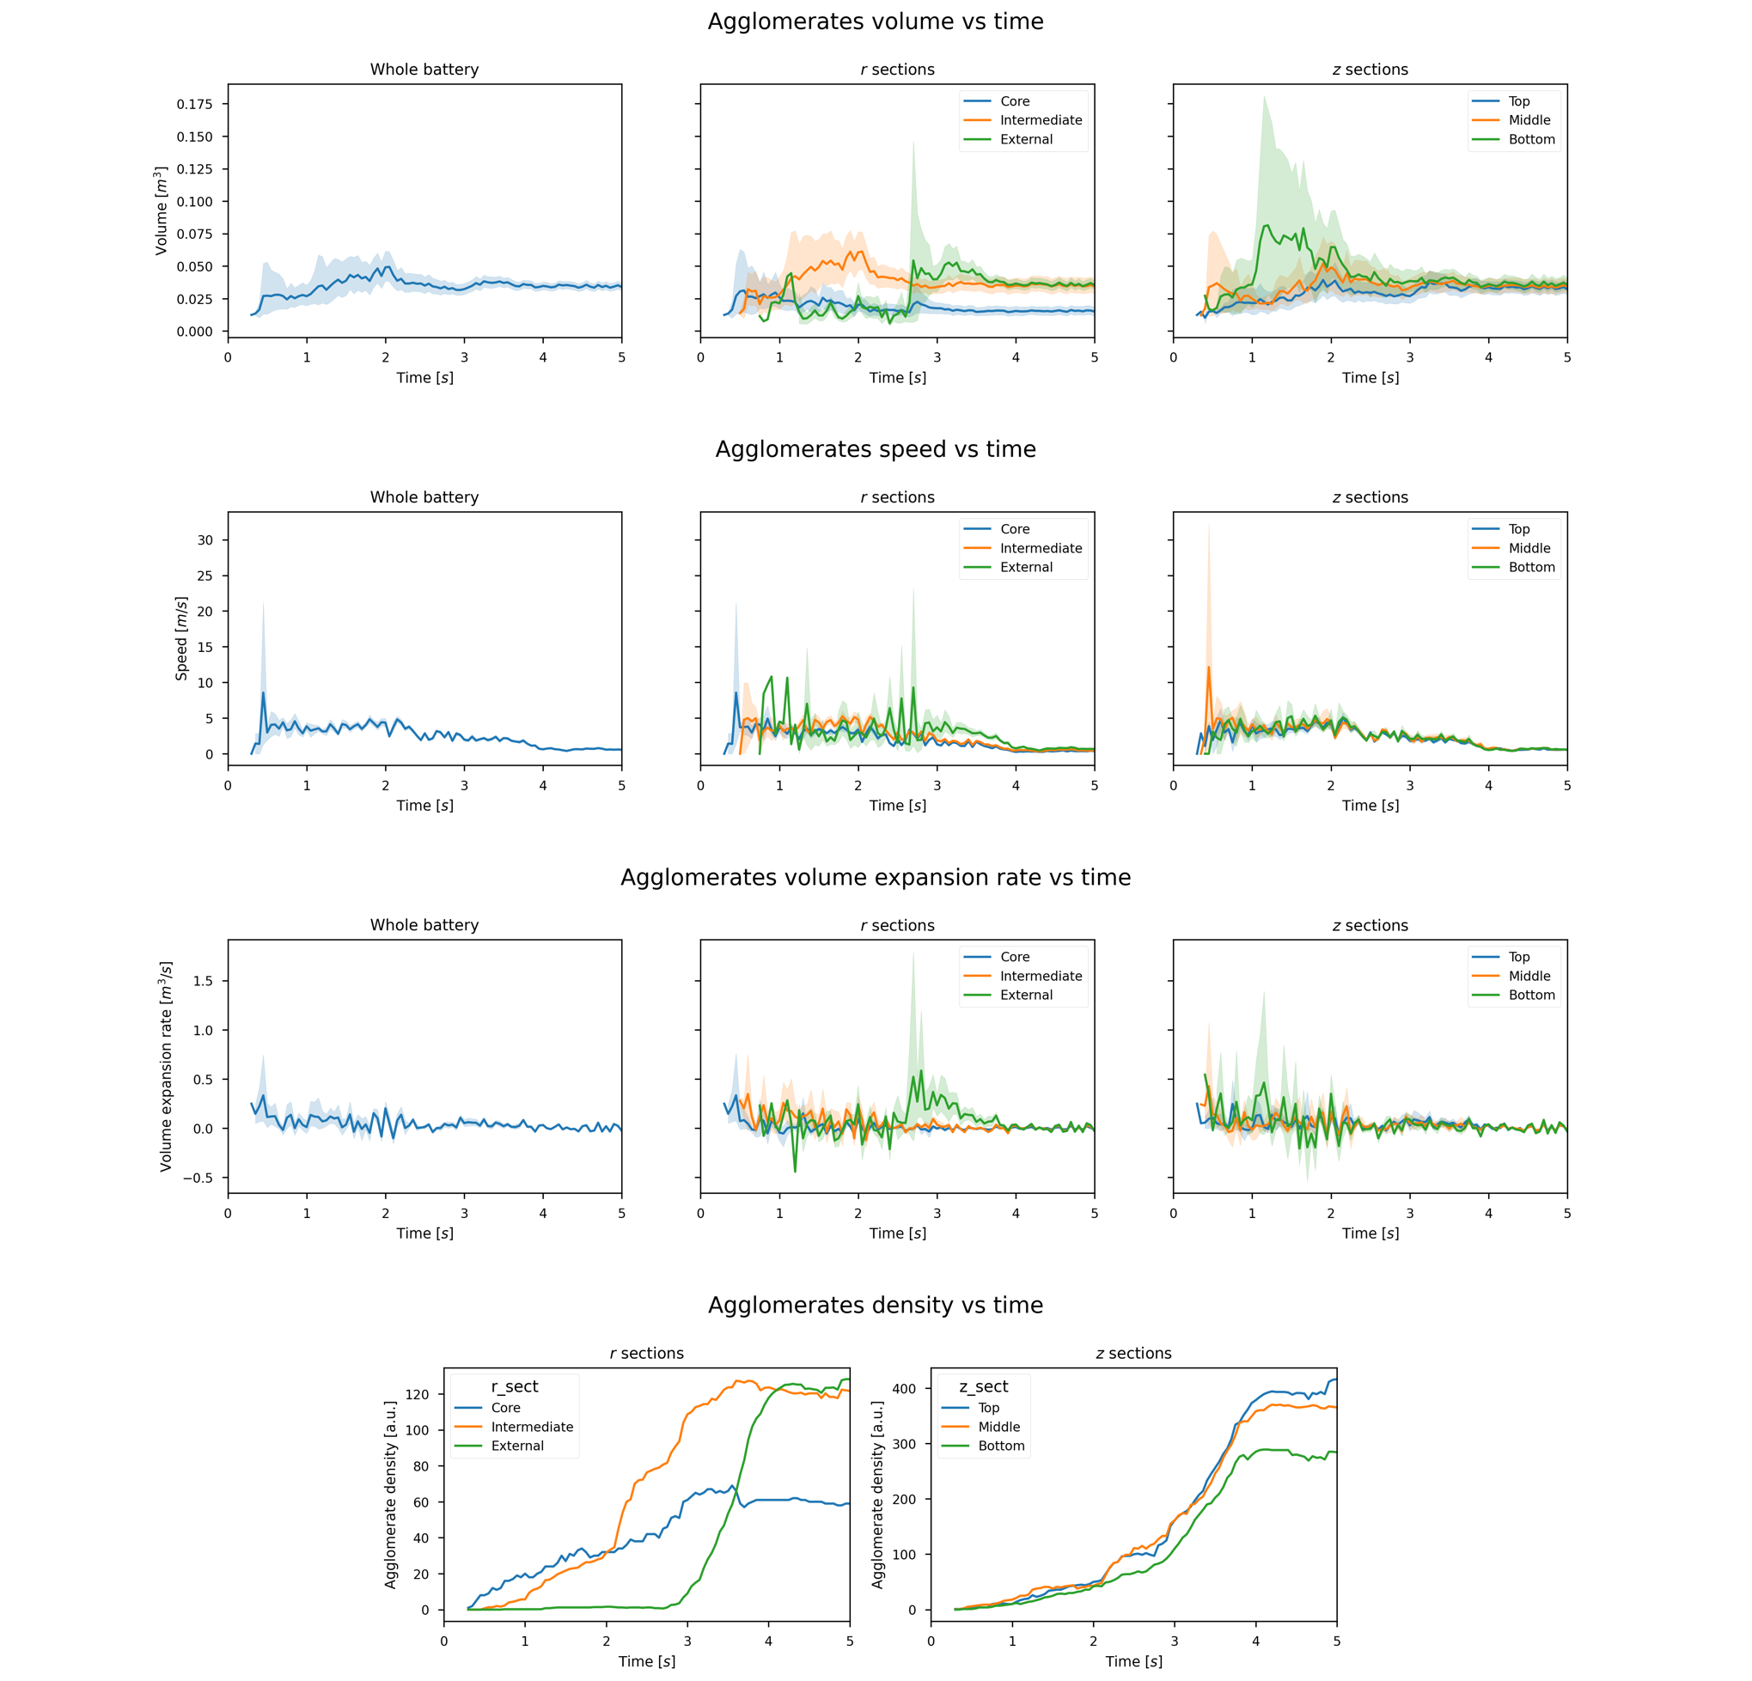5

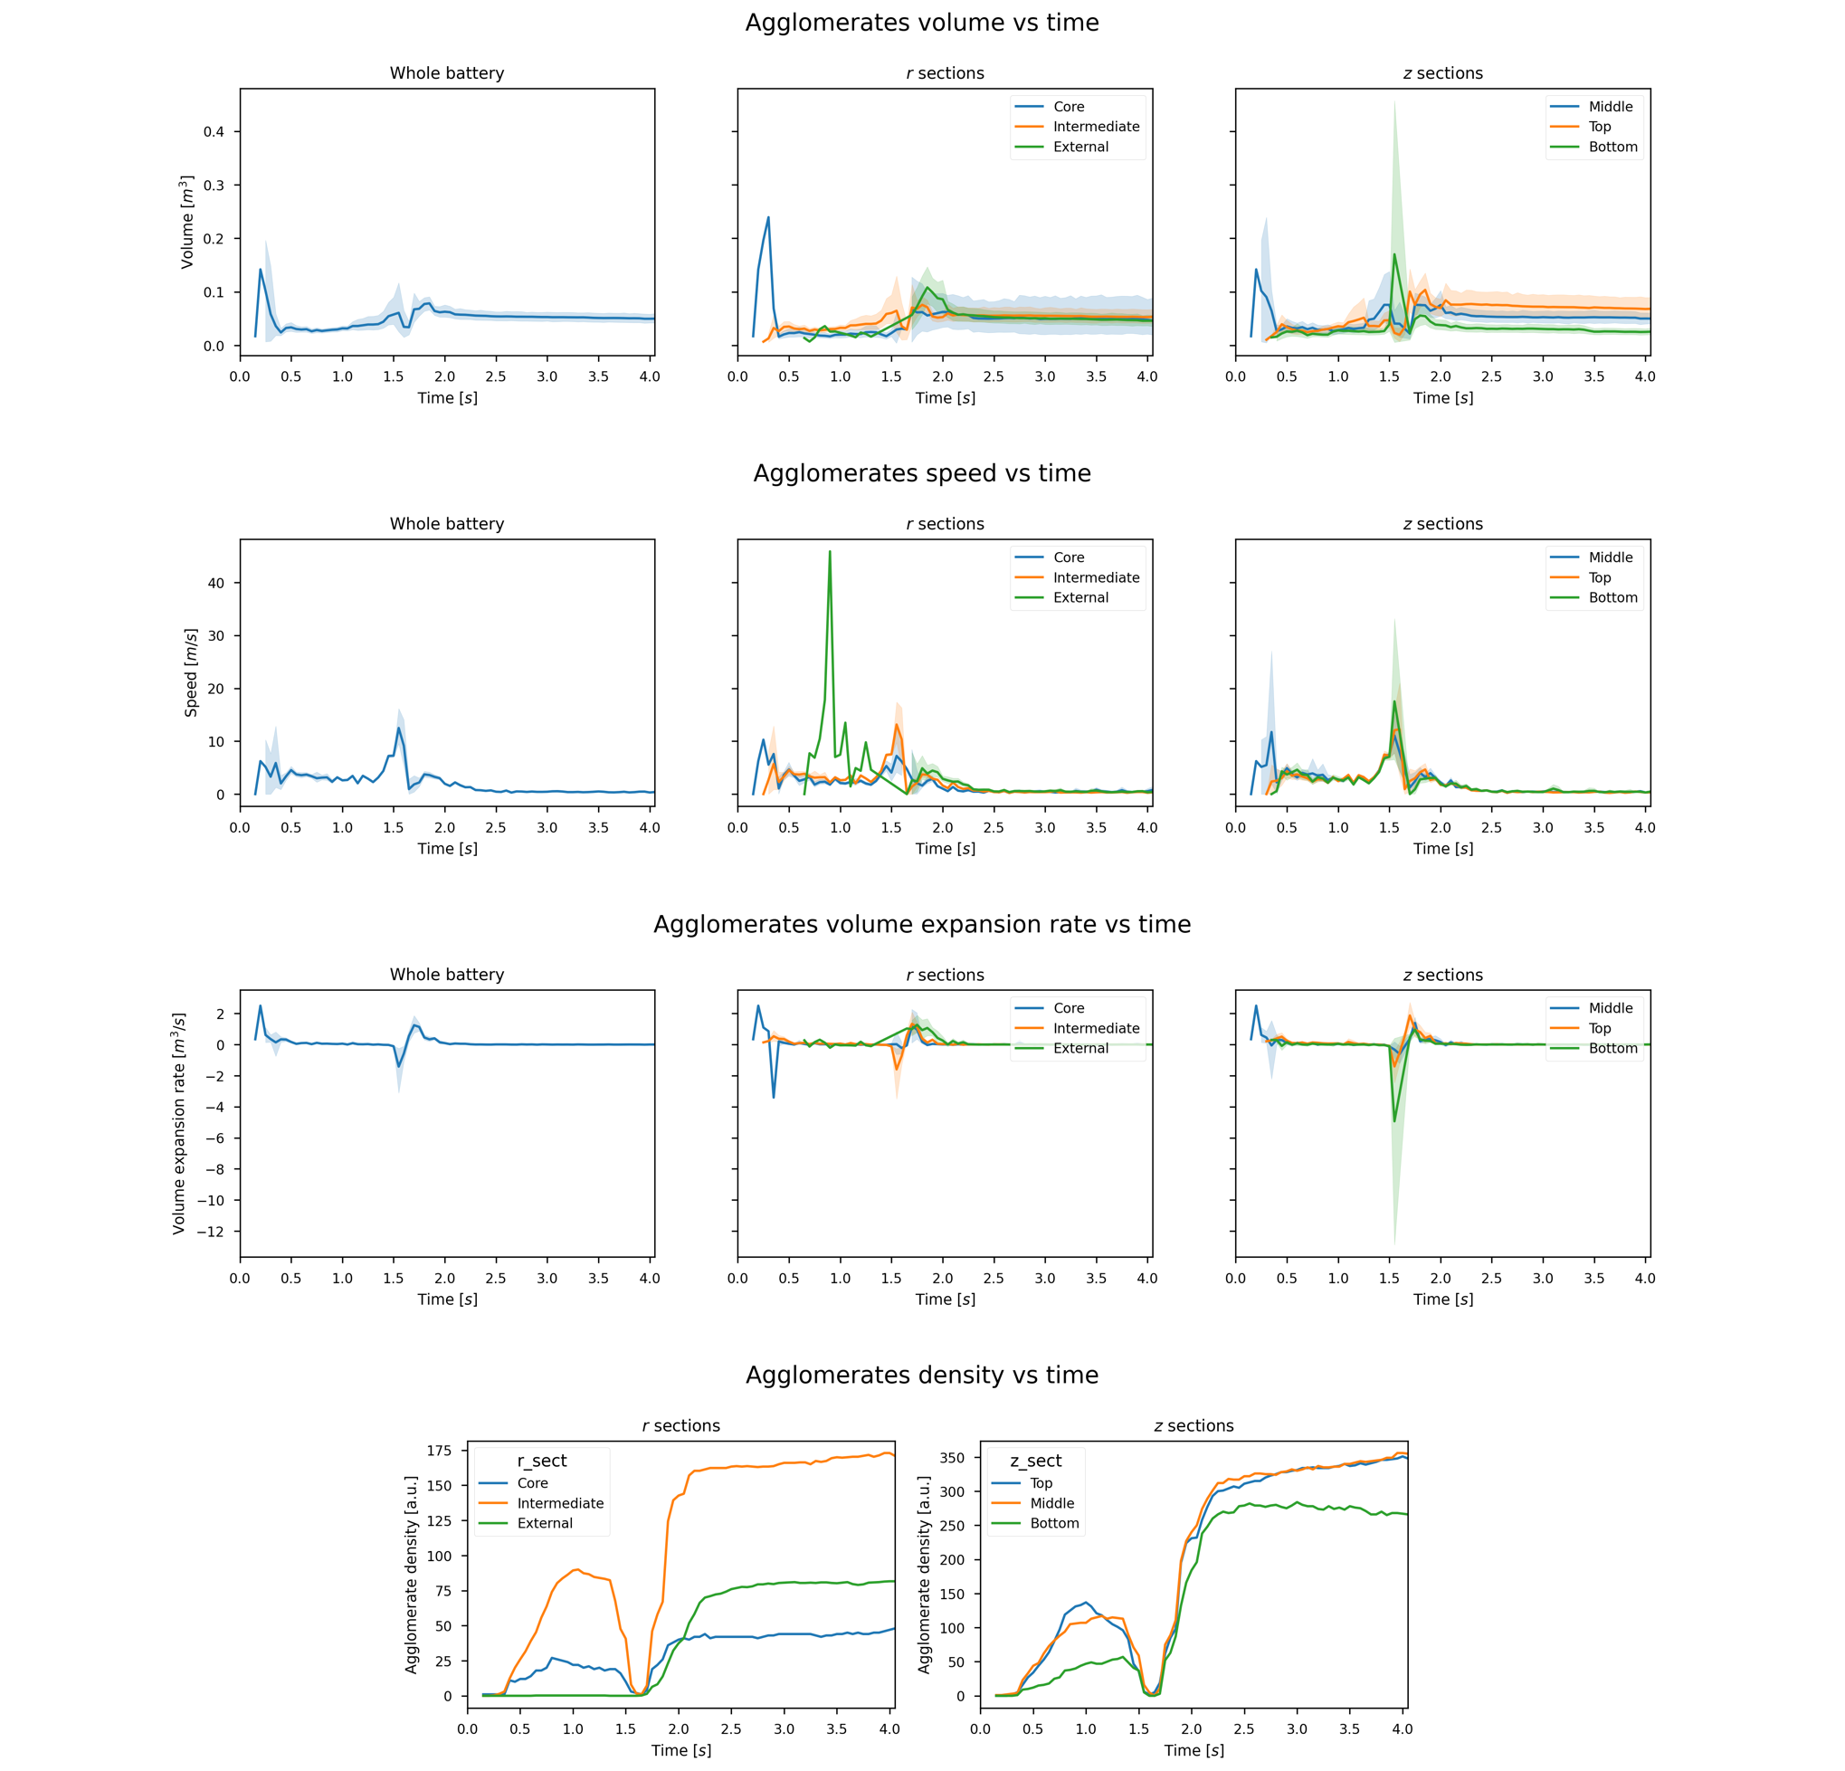VCT5A_FT_H_Exp2

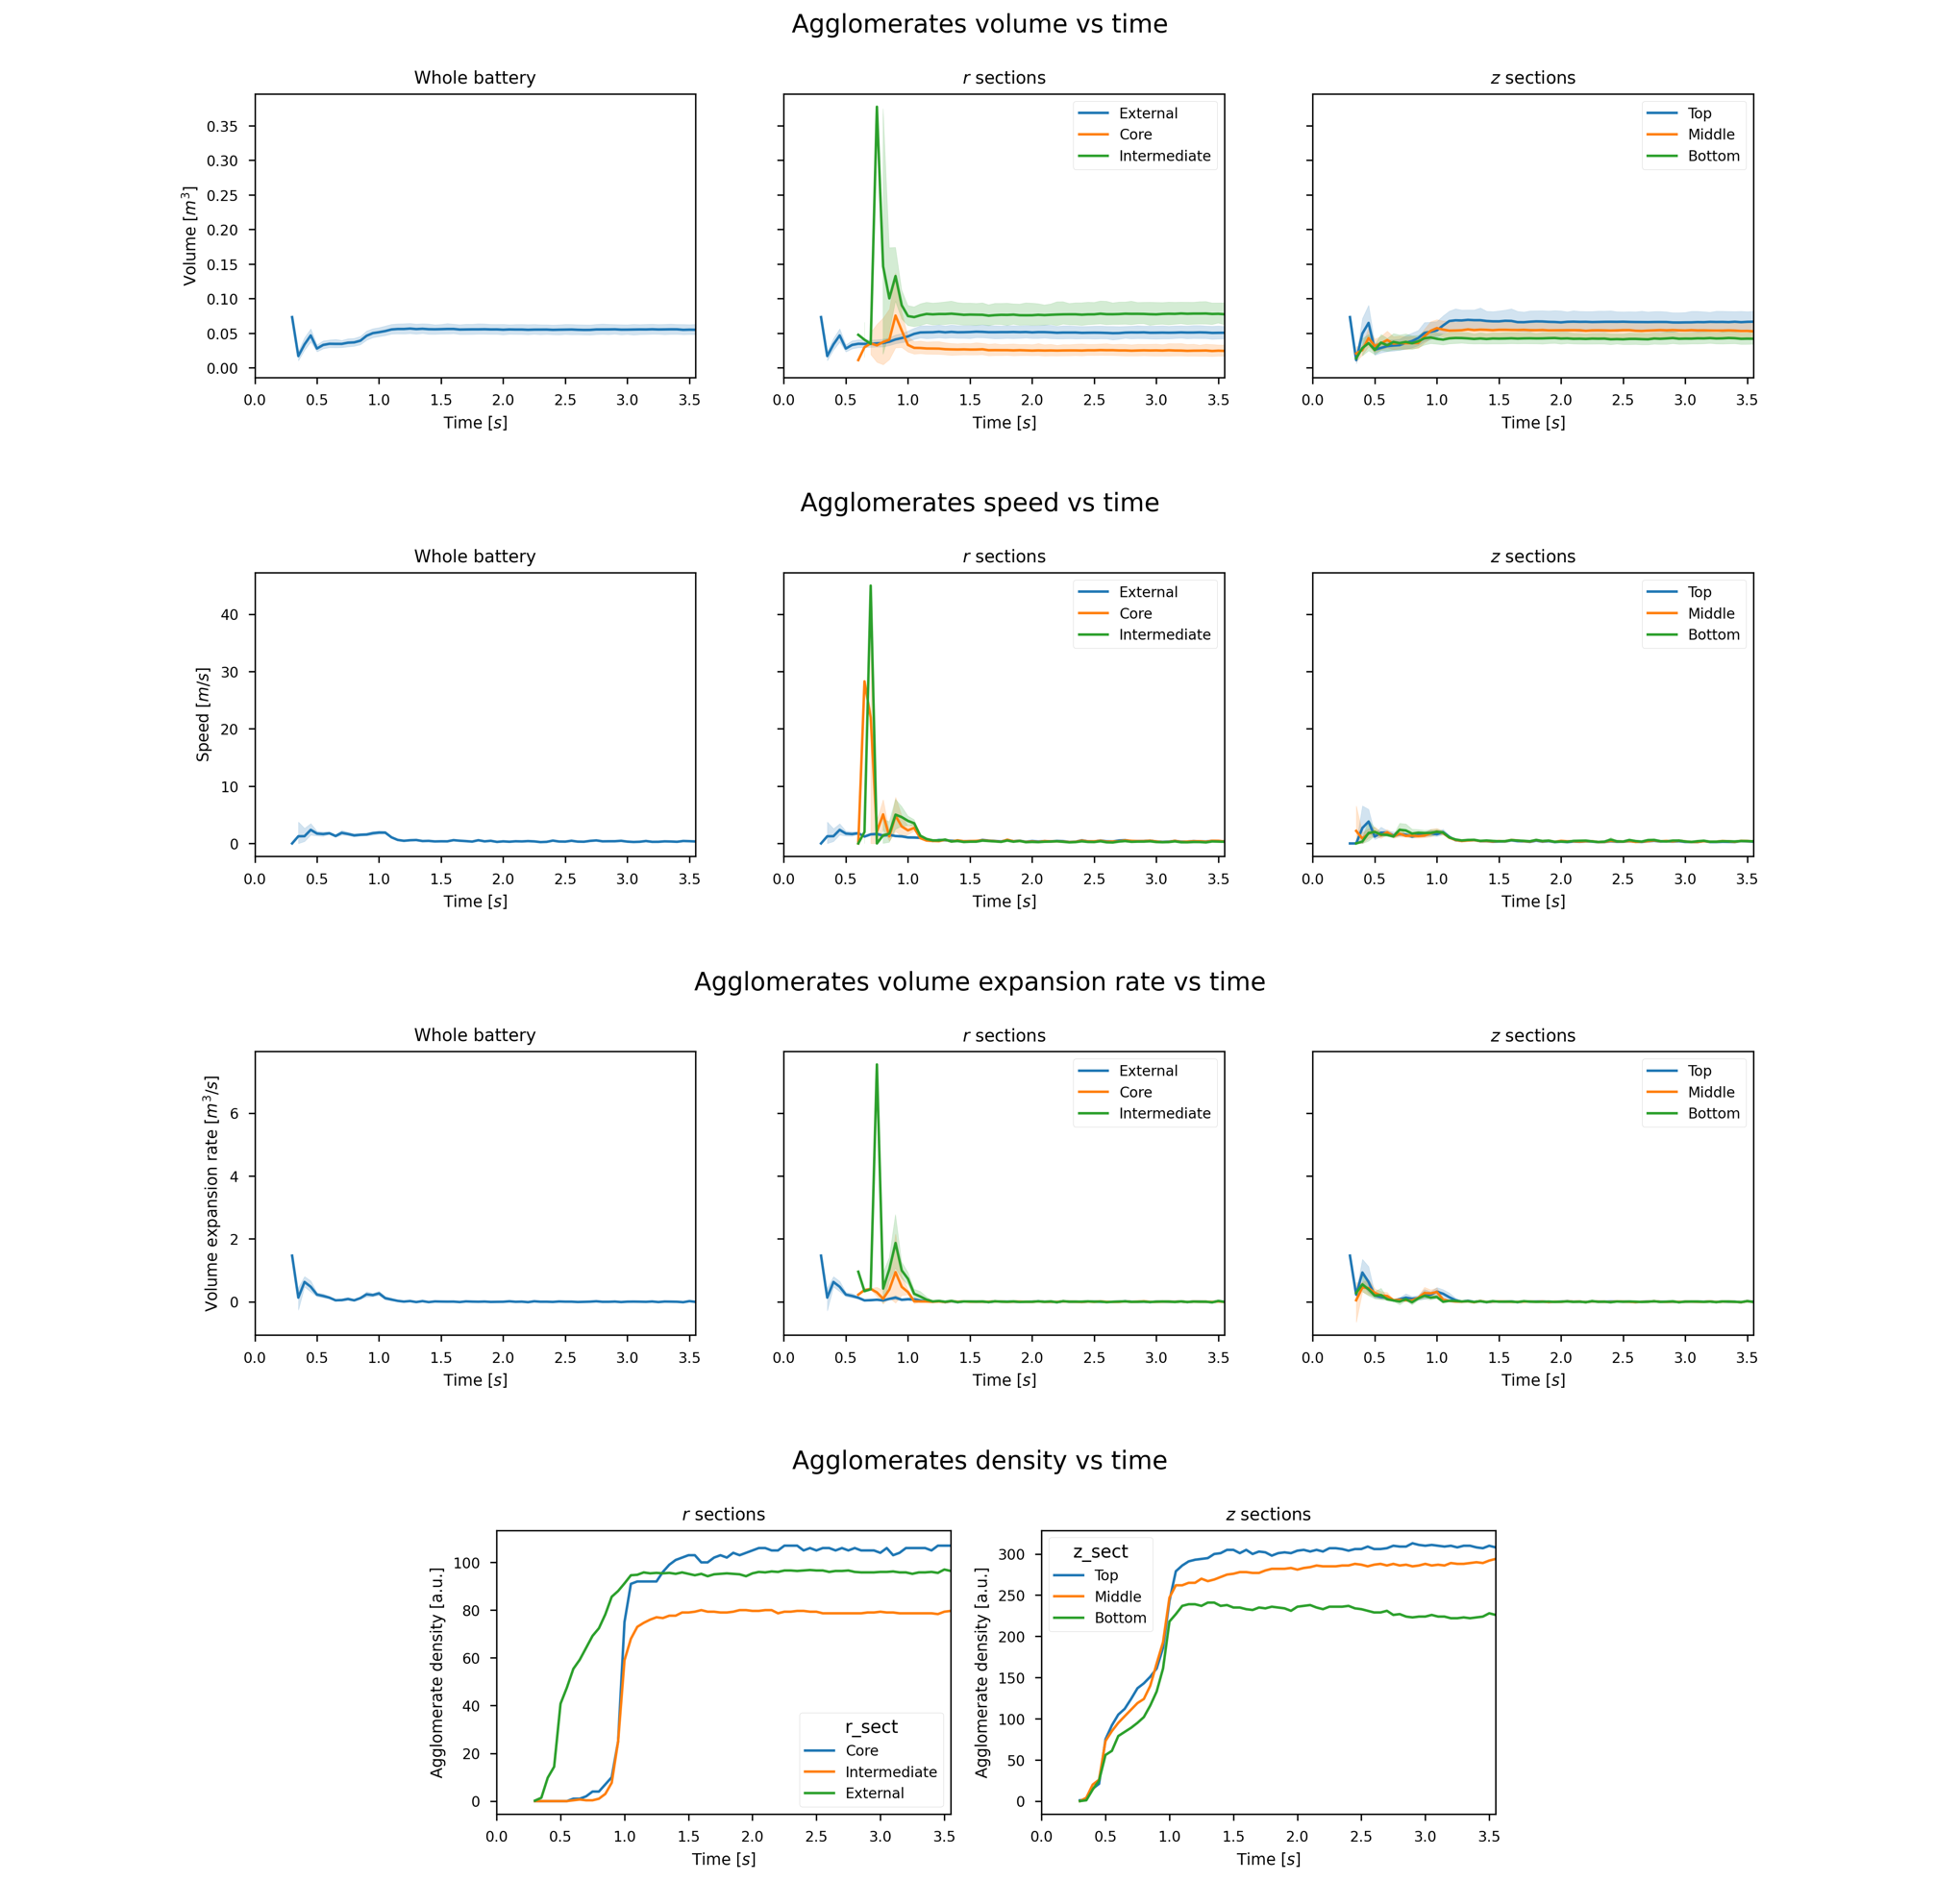VCT5A_FT_H_Exp5